**GENERAL INTEGRATED SCIENCE**

**TASK 8: Atoms and thE PERIODIC TABLE**

**NAME: _________________________________________________**

**WEIGHTING: 5% Total Marks: 48**

1. Describe one thing that makes metals different from non-metals (2 marks)

|  |
| --- |
|  |
|  |
|  |
|  |
|  |
|  |

1. Give two examples of metallic elements (2 marks)

|  |
| --- |
|  |
|  |
|  |

1. Give two examples of elements that are non-metals (2 marks)

|  |
| --- |
|  |
|  |
|  |

1. State the atomic symbol, atomic mass and atomic numbers of the below elements
   1. Sodium (3 marks)
      1. Atomic symbol:

|  |
| --- |
|  |
|  |

* + 1. Atomic mass:

|  |
| --- |
|  |
|  |

* + 1. Atomic number:

|  |
| --- |
|  |
|  |

* 1. Sulfur (3 marks)
     1. Atomic symbol:

|  |
| --- |
|  |
|  |

* + 1. Atomic mass:

|  |
| --- |
|  |
|  |

* + 1. Atomic number:

|  |
| --- |
|  |
|  |

* 1. Argon (3 marks)
     1. Atomic symbol:

|  |
| --- |
|  |
|  |

* + 1. Atomic mass:

|  |
| --- |
|  |
|  |

* + 1. Atomic number:

|  |
| --- |
|  |
|  |

* 1. Helium (3 marks)
     1. Atomic symbol:

|  |
| --- |
|  |
|  |

* + 1. Atomic mass:

|  |
| --- |
|  |
|  |

* + 1. Atomic number:

|  |
| --- |
|  |
|  |

* 1. Hydrogen (3 marks)
     1. Atomic symbol:

|  |
| --- |
|  |
|  |

* + 1. Atomic mass:

|  |
| --- |
|  |
|  |

* + 1. Atomic number:

|  |
| --- |
|  |
|  |

* 1. Carbon (3 marks)
     1. Atomic symbol:

|  |
| --- |
|  |
|  |

* + 1. Atomic mass:

|  |
| --- |
|  |
|  |

* + 1. Atomic number:

|  |
| --- |
|  |
|  |

* 1. Copper (3 marks)
     1. Atomic symbol:

|  |
| --- |
|  |
|  |

* + 1. Atomic mass:

|  |
| --- |
|  |
|  |

* + 1. Atomic number:

|  |
| --- |
|  |
|  |

1. Label the diagram of an oxygen atom with the **terms below** (3 marks)

Nucleus

Electron

Proton

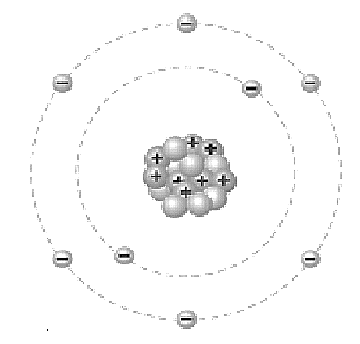

1. For each of the below molecules, name how many atoms of each element are present. Be sure to use the full name of each element
   1. CO

(2 marks)

|  |
| --- |
|  |
|  |
|  |

* 1. P4

(1 mark)

|  |
| --- |
|  |
|  |
|  |

* 1. Na2CO3

(3 marks)

|  |
| --- |
|  |
|  |
|  |

* 1. P2O5

(2 marks)

|  |
| --- |
|  |
|  |
|  |

* 1. NH3

(2 marks)

|  |
| --- |
|  |
|  |
|  |

* 1. FeSO4

(3 marks)

|  |
| --- |
|  |
|  |
|  |

* 1. GaCl3

(2 marks)

|  |
| --- |
|  |
|  |
|  |

* 1. SiO2

(2 marks)

|  |
| --- |
|  |
|  |
|  |

1. Describe the difference between an element and a compound (2 marks)

|  |
| --- |
|  |
|  |
|  |
|  |